Lesson plan 3: Using variables
About the lesson
This lesson introduces students to the concept of variables and how they can be used to temporarily store data. They will learn how an input can be taken from the user and used to form an output and will perform a series of tasks to demonstrate their understanding.
Learning objectives
By the end of this lesson, students will:
- know how to input and output data using Scratch
- be able to define the term 'variable'
- know how to use variables to temporarily store data in Scratch
- be able to apply concatenation to join strings and variables.
National Curriculum
The following subject content from the KS3 National Curriculum is included in this lesson:
- Use two or more programming languages, at least one of which is textual, to solve a variety of computational problems.
Links
There are links to English and the need for precise instructions that are carried out in order. There are also links to maths and the internal angles of shapes.
Key terminology
variable, value, input, concatenation, output
Teaching and learning activities
Share the objectives for the lesson with students (Slide 2 of Lesson 3 presentation).
Starter
Ask students to complete Activity 3.1: Using variables in calculations (Interactive 3.1, Slide 3).
This activity will enable you to assess students' ability to work out the values of variables prior to any formal teaching. The activity is a self-marking quiz, and you could turn it into a competition to see who gets the most correct answers.

Part 1
- Explain what a variable is and why and how it is used in programming (Slides 4–5 and page 46).
- Show students how variables work in Scratch (Slide 6 and Video 3.1, and page 46).
- Scratch is very helpful with variables, because it shows the value currently stored in a variable on the stage.
- Explain the new blocks that students will be using today and where they can find them in the palette (Slide 7–10 and page 46).
Part 2
Ask students to complete Activity 3.2: Asking your name (Page 47/Worksheet 3.2, plus Evidence document 3 and Slide 11).
- There is a GIF in the presentation to show students what should happen when they run the program. The activity also contains an extension activity.
- If students are struggling with the extension activity, encourage them to write down what they want the cat to say and then circle the variables to help them identify how to construct the joins.
Common misconceptions
Some students may think that a variable can hold multiple values, and may not understand that the contents is overwritten each time a new input is taken. Encourage them to list all the different pieces of information that a program will need to store, and then to identify a suitable name for each variable that will be needed, that describes what it will be storing.

Example answers
(See screenshot below and Activity 3.2 solution)
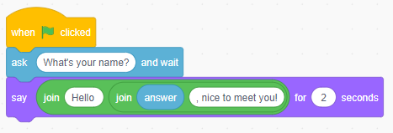
Extension
(See screenshot below and Activity 3.2 Extension solution)
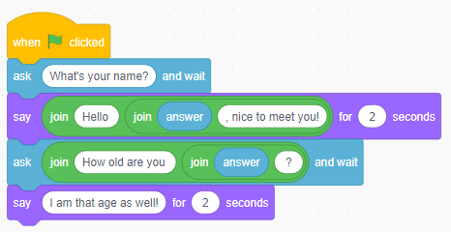
Ask students to complete Activity 3.3: Shopping list (Page 47/Worksheet 3.3, plus Evidence document 3 and Slide 12).
There is a GIF in the presentation to show students what should happen when they run the program.

Example answers
(See screenshot below and Activity 3.3 solution)
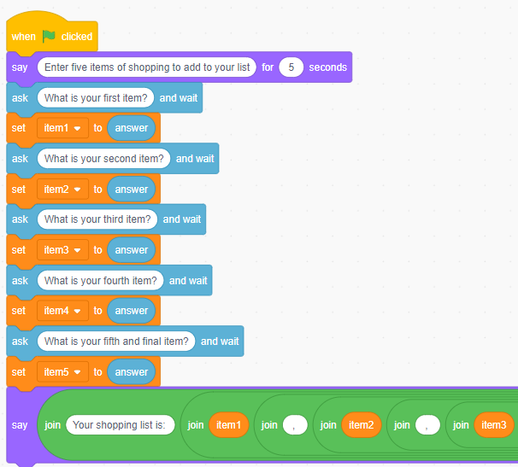
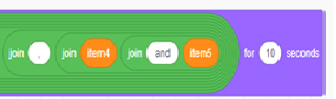

Part 3
Ask students to complete Activity 3.4: Chatbot aka ‘Cat Bot’ (Page 47/Worksheet 3.4, plus Evidence document 3 and Slide 13).
There are GIFs in the presentation to show students what should happen when they run the programs. The activity also contains an extension activity.
Example answers
(See screenshot below and Activity 3.4 solution)
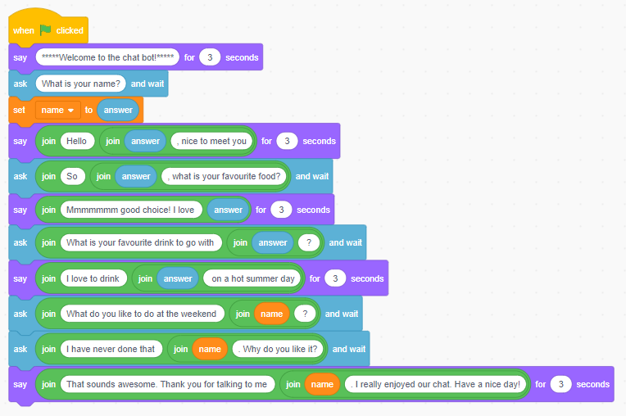
Extension
(See screenshot below and Activity 3.4 Extension 1 solution)
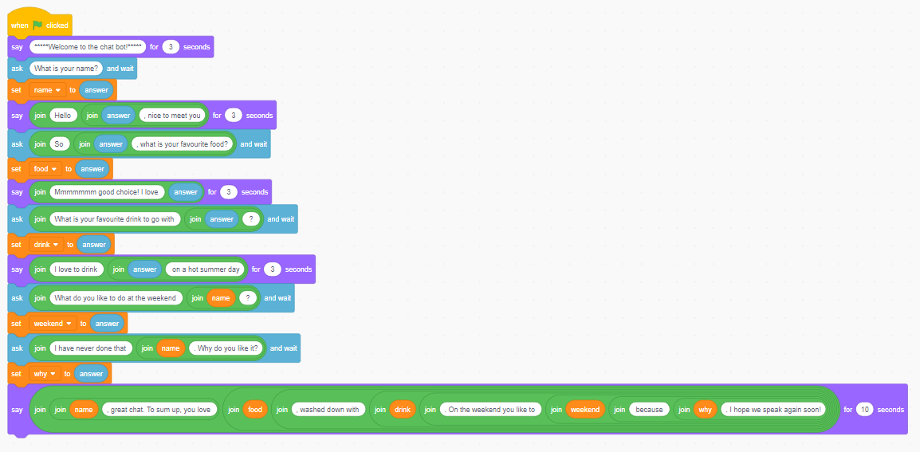
Plenary
Check students' knowledge and understanding with a short question and answer session linked to the learning objectives for the lesson (Slides 14–19).
- What is a variable? (Slide 14)
(Example answer: A variable is a container that temporarily holds a value
[a number or a piece of text]. The value can be retrieved within the program using its variable name.)
- In which category would you find the block to display something on screen? (Slide 15)
(Answer: Looks, the purple category)
- In which category would you find the block to ask a question? (Slide 17)
(Answer: Sensing, the light blue category)
- What is wrong with this code? (Slide 18)
(Example answer: It will output Hello and the user's age rather than their name. The wrong variable has been used in the 'say' block.)
- How many variables are there in this code? What are the names of the variables? (Slide 19) (Answer: There are three variables: name, age and favsport.)
- What would the cat say on screen when this program is run? (Slide 20)
(Answer: Hello Simon, you are 24 and your favourite sport is Rugby)
Homework
Ask students to complete any activities they did not finish during the lesson.
Ask students to complete Quiz 3 (Slide 20).
Stretch activities
Some students will complete the activities in this lesson quickly. They could be encouraged to extend their programs to ask additional questions, storing the answers and using them in more complex outputs that join several pieces of data together.
Support activities
Students who find the concept of variables hard to understand will benefit from focusing on taking just one input, storing it in a variable and then using it in an output. Once they are confident with doing this, they should extend their program to take in a second input, which is stored and used, before trying to create an output that joins together the values from both inputs. They may find it helpful to work with a partner to complete some of the coding activities.
A series of videos about drawing shapes in Scratch can be found at: www.youtube.com/channel/UCzyj8fEcs3AFDjMl91PlkxQ.

